### 

**Perovskite data** **2**

**Bowing [-0.01, 0.01]** **3**

**Mix proportion of elements [0, 100]% (from to )** **4**

**Temperature [0, 500] K** **5**

**Tension [-6, 6]%** **6**

**Results discussion** **7**

High values on way to 7

Gap in R-point 8

**Mix proportion of elements [0, 100]%** **9**

### Perovskite data

[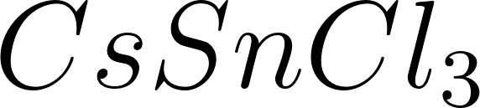](https://www.codecogs.com/eqnedit.php?latex=CsSnCl_3#0):

"Eg": 2.69,

"delta": 0.45,

"gamma_1": 6.4,

"gamma_2": 2.5,

"gamma_3": 0.8,

"mh": 0.140,

"Ep": 34.7,

"a": 5.560,

"alpha": 0.7 * 0.001, # eV/K

"a^c" : -0.808,

"a^v" : -5.752,

"C_11" : 49.35

"C_12" : 8.77

[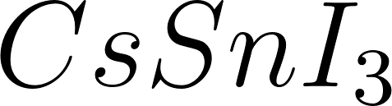](https://www.codecogs.com/eqnedit.php?latex=CsSnI_3#0):

"Eg": 1.01,

"delta": 0.42,

"gamma_1": 13.0,

"gamma_2": 5.6,

"gamma_3": 2.1,

"mh": 0.069,

"Ep": 29.9,

"a": 6.219,

"alpha": 0.35 * 0.001, # eV/K

"a^c" : -0.052,

"a^v" : -3.651,

"C_11" : 21.34

"C_12" : 1.22

Perovskite:

(Values after interpolation with most used set of variables)

Material with 50% of each component.

Temperature = 300K

Bowing = 0

Tension = 0%

'Eg': 1.85, (in 0 K)

'delta': 0.435,

'gamma_1': 9.7,

'gamma_2': 4.05,

'gamma_3': 1.45,

'mh': 0.1045,

'Ep': 32.3,

'a': 5.8895,

'alpha': 0.000525,

'a^c': -0.430,

'a^v': -4.70,

'C_11': 35.345,

'C_12': 4.995,

'Eg_with_temperature': 2.00,

'E_VB_with_temperature': -1.82,

'E_CH_with_temperature': 359,

'E_CL_with_temperature': -151,

'E_CS_with_temperature': 259,

### 

### Bowing [-0.01, 0.01]

Values of bowing shown in the GIF below are extremely small but it affects results a lot. E.g. the gap is opening very fast. Further in the work bowing is not considered, nevertheless I consider it important to show how much even small bowing can change and that it is important to consider bowing in future work on perovskite.

### 

Data:

* Temperature = 300K
* Tension = 0
* Mix proportion = 0.5 [50% of [](https://www.codecogs.com/eqnedit.php?latex=CsSnCl_3#0) and [](https://www.codecogs.com/eqnedit.php?latex=CsSnI_3#0)]

### Mix proportion of elements [0, 100]% (from to )

Proportion of components is most important for a gap. Values outside point R are not changing that fast like on point R, and when further from R then change is smaller.

### 

Data:

* Temperature = 300K
* Bowing = 0
* Tension = 0

### 

### Temperature [0, 500] K

Rising temperatures open the gap and increase values on every point not only on R. Spectrum 0-500 K is large for the real world, most often temperature on Earth surface is ~300 K and does not fluctuate more than 50 K. It is important to consider temperature but for designing semiconductors there are more important components.

### 

Data:

* Bowing = 0
* Tension = 0
* Mix proportion = 0.5 [50% of [](https://www.codecogs.com/eqnedit.php?latex=CsSnCl_3#0) and [](https://www.codecogs.com/eqnedit.php?latex=CsSnI_3#0)]

### 

### Tension [-6, 6]%

Tension does not change the gap on point R and going further from point R it changes less and less of values. The most important change is visible on the GIF below and it is this change between CH and CL bands.



Data:

* Temperature = 300K
* Bowing = 0
* Mix proportion = 0.5 [50% of [](https://www.codecogs.com/eqnedit.php?latex=CsSnCl_3#0) and [](https://www.codecogs.com/eqnedit.php?latex=CsSnI_3#0)]

### Results discussion

#### High values on way to

As seen below, values on the 15% way from R to [](https://www.codecogs.com/eqnedit.php?latex=%5CGamma#0) are high, more than 5 eV, and in the point R there is like 2 eV. That large difference is not expected, and that is why I need to discuss that.

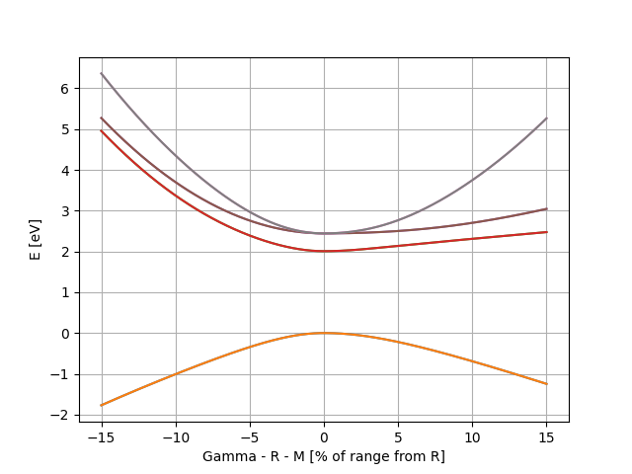

Point R have values [0,0,0], and 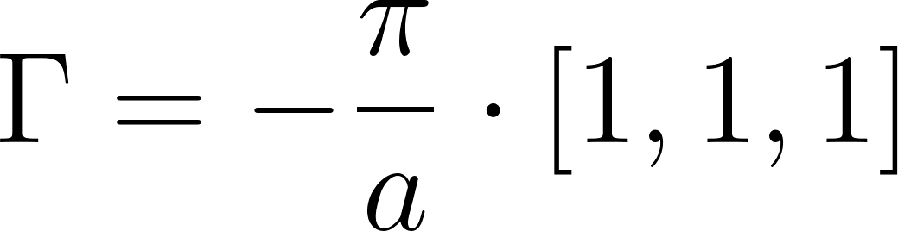, we know that a = 5.8895 then we take 15% of the total [](https://www.codecogs.com/eqnedit.php?latex=%5CGamma#0) value to calculate eigenvalues from a given Hamiltonian. Therefore we get [](https://www.codecogs.com/eqnedit.php?latex=15%25%20%5CGamma%20%3D%20%5B-0.082%2C%20-0.082%2C%20-0.082%5D%20#0) (to note:[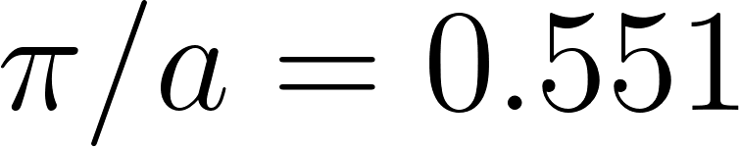](https://www.codecogs.com/eqnedit.php?latex=%5Cpi%20%2F%20a%20%3D%200.551#0)). We have point k and going further we calculate eigenvalues of given Hamiltonian

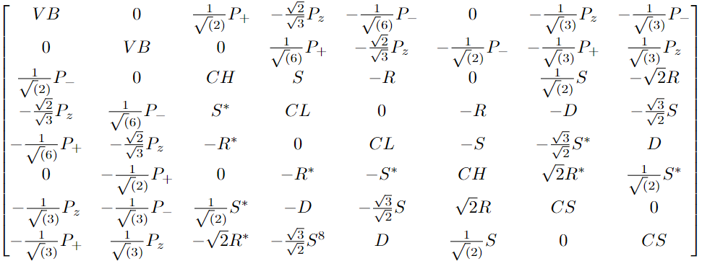

Therefore for set point k we get following eigenvalues (increasing order)

-1.54357, -1.54357, 5.15404, 5.15404, 5.46289, 5.46289, 6.06990, 6.06990

Returned values are the same as those on the chart. We choose k-point manually and we know that it is what we want, further we calculate eigenvalues of the given Hamiltonian after needed preparation to update data for chosen k-point. Those calculations show that the value range is correct even if not expected.

#### Gap in R-point

Consider the following variables: mix proportion, temperature and tension. The most important is the mix proportion from which we obtain the range of the gap [1.01 - 2.69], further temperature is opening the gap, but even for 500 K difference contribution to the gap from temperature is small and can be easily reduced by choosing a different mix proportion. Tensin has no impact on the gap.

For future work on perovskite it can be important to consider even small bowing because it affects the gap rapidly with small change in bowing value. The larger bowing, the larger the gap there is.

### Mix proportion of elements [0, 100]%

From [](https://www.codecogs.com/eqnedit.php?latex=%5CGamma#0) through R to M

This GIF is not important for this work but to show how those calculation work on whole way [](https://www.codecogs.com/eqnedit.php?latex=%5CGamma#0) - R - M. Pure curiosity, to see where is the usability range for those calculations.